TASK 11 – Implement, Test and Defend the Design
Student Name: B. Muni Chandini
Register Number: 192524283

1. Test Table
Test Case | Input | Expected Result | Actual Result | Pass/Fail
Normal entry (TwoWheeler) | TN01A1111, visitor | Slot allocated, ticket issued |  | Pass
Normal entry (Car + pass) | TN02B2222, monthly pass | Slot allocated, fee will be 0 |  | Pass
Normal entry (ElectricCar) | TN03C3333 | Slot allocated |  | Pass
Boundary – Parking Full | 4th vehicle | “Parking Full” message |  | Pass
Exit + Fee (90 min TwoWheeler) | exit after 90 min | Fee = Rs 20 |  | Pass
Exit + Staff | staff vehicle | Fee = Rs 0 |  | Pass
Exit + EV charging | 120 min + 10 kWh | Fee = 60 + 120 = Rs 180 |  | Pass
Invalid – unknown vehicle | TN99Z9999 | Error message |  | Pass
Invalid – duplicate entry | same regNo while parked | Error message |  | Pass
2. How well the design follows OOP principles
- Encapsulation: All fields private, validation in constructors
- Inheritance: Vehicle → TwoWheeler / Car → ElectricCar
- Polymorphism: calculateFee() works correctly for all types via dynamic dispatch
- Abstraction: Abstract class + Interface (Chargeable)
3. One limitation
- Currently uses a simple 2-D array. If number of slots per floor becomes very different or very large, switching to List<List<String>> or a Map would be better.
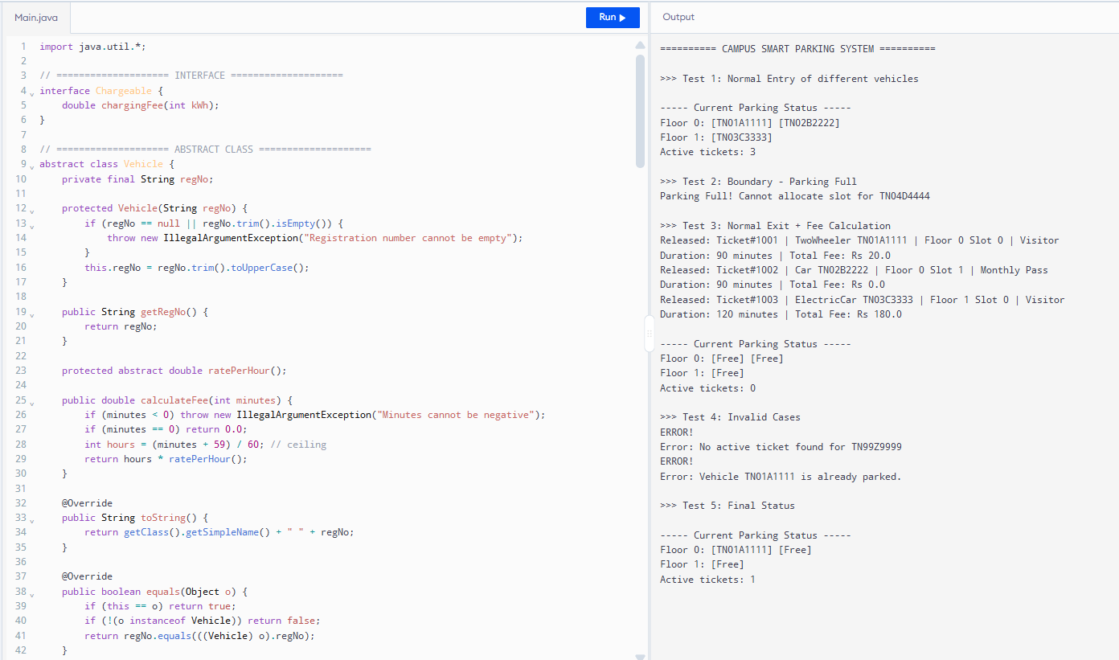
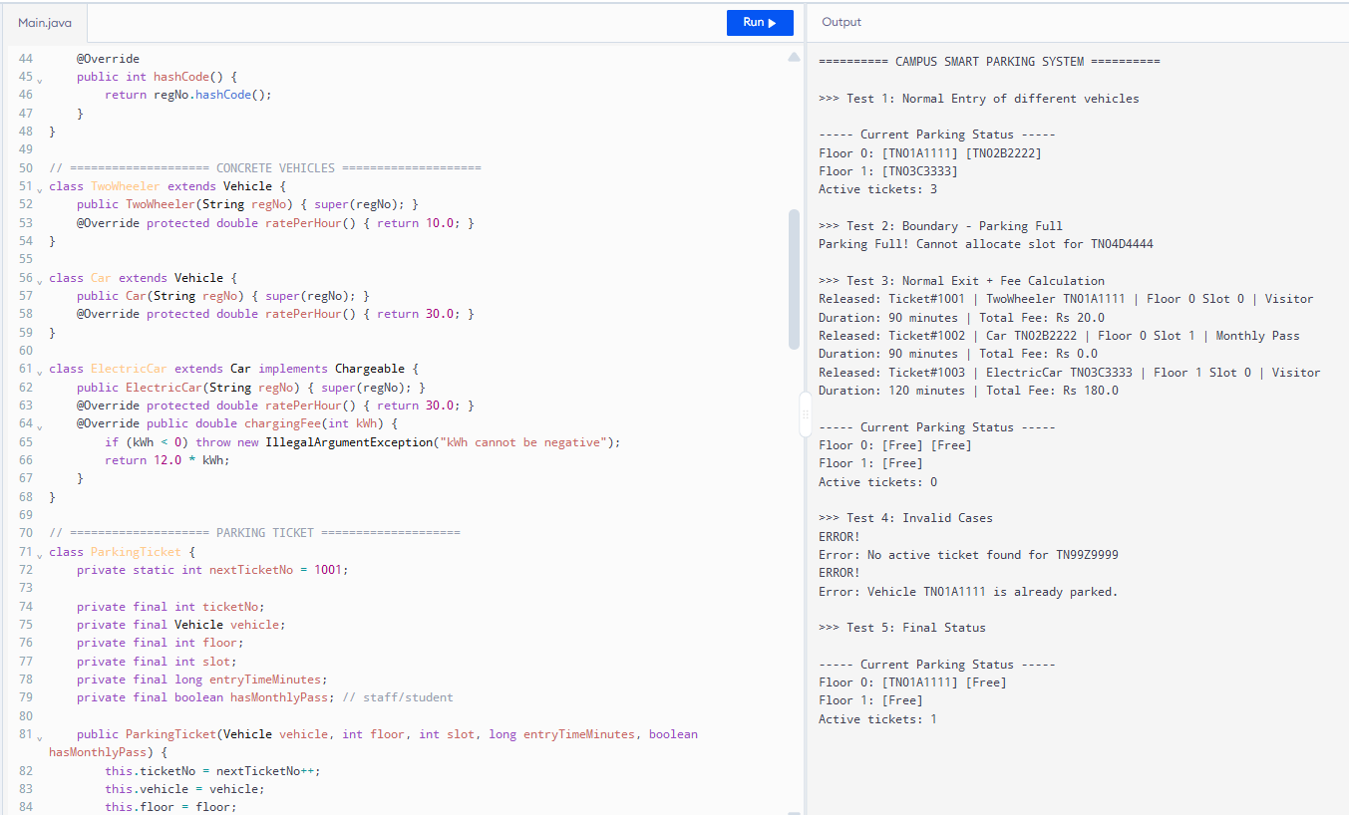
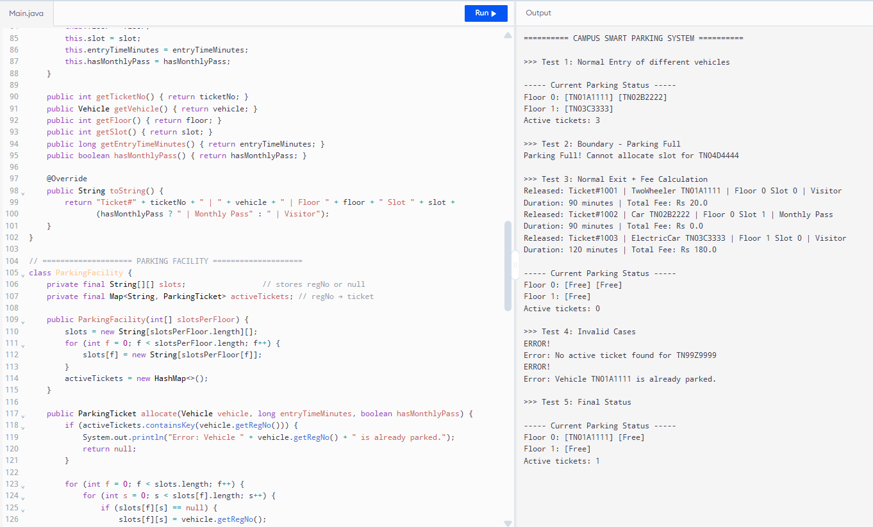
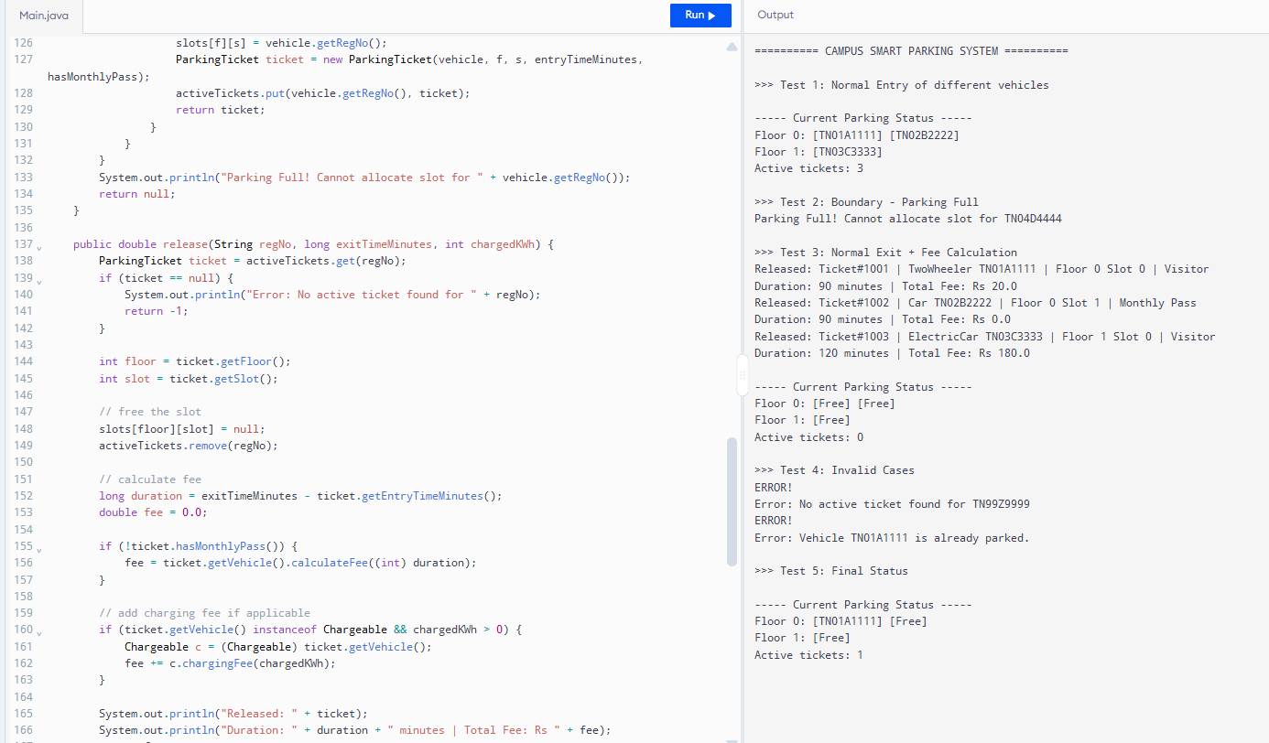
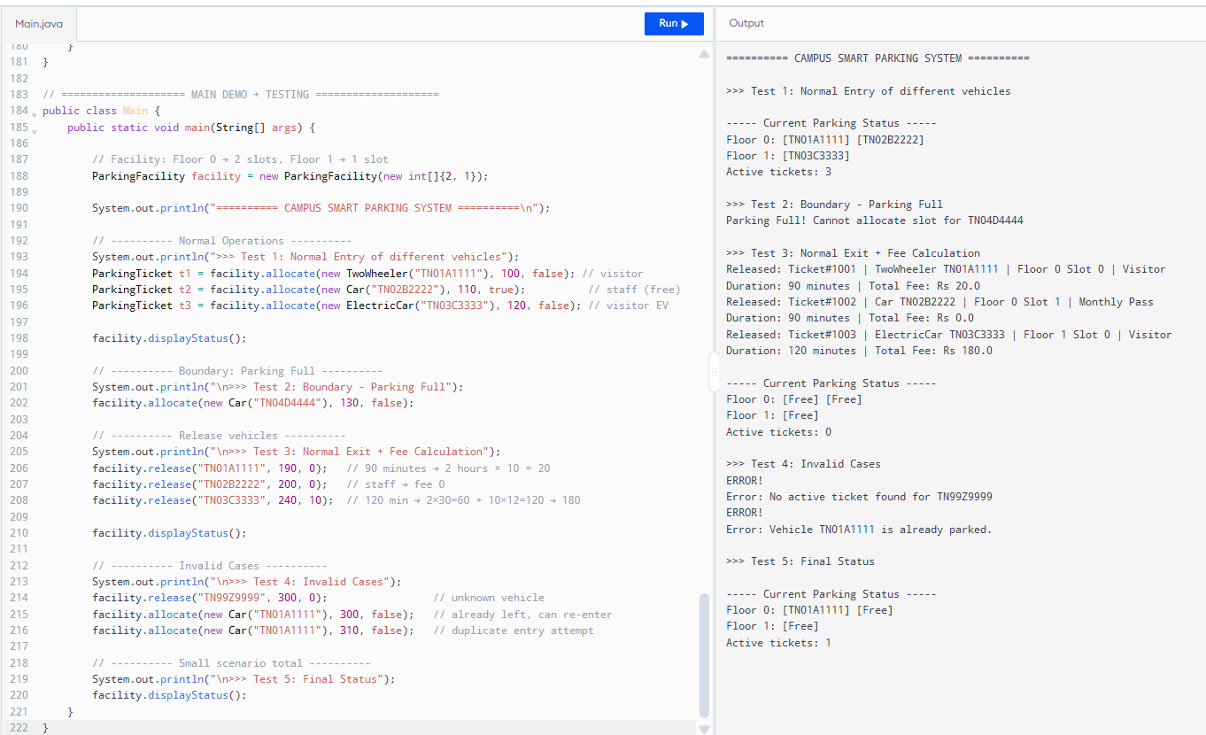
4. Alternative Concept and Complexity Analysis
Current: Active tickets stored in HashMap<String, ParkingTicket>
Alternative: ArrayList<ParkingTicket>
Operation | HashMap (my design) | ArrayList
Find ticket on exit | O(1) | O(n)
Space for n vehicles | O(n) | O(n)
Conclusion: HashMap is clearly better for exit processing.

